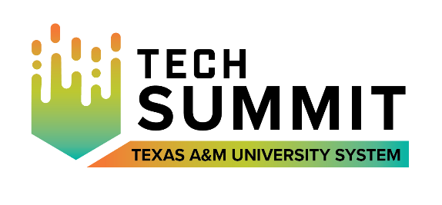
Dear [insert name],
I’m reaching out because I want to attend the 2022 A&M System Technology Summit scheduled for virtually the afternoons of September 27 and 28.
The conference is a premier event for A&M System IT professionals, and is packed with timely content, prominent presenters and multiple ways for me to engage, learn, and connect with colleagues and advance my professional skills.
Some of the skills I am particularly interested in strengthening and emphasizing are:
- [List the skill sets you’re interested in learning about].
I believe this conference will help me build confidence and help me develop the skills I’ve listed, which I can apply immediately to my career.
Since this conference is virtual, I don’t have to travel. Full-conference registration is [insert rate based on date registering – Early Bird or General Admission].
Thank you for considering allowing me to attend this unique professional development and networking opportunity.
Sincerely,
[Signature]

