OneDrive Quick Start
What is Microsoft OneDrive? 1
How to set up OneDrive 2
Where are my files? 4
Where are files that are shared with me? 4
How can I access these shared files directly from my computer? 5
How can I share files? 6
How can I access files when I’m away from my work computer? 7
Some of my shortcuts stopped working, how can I fix that? 7
What do the icons next to each file mean? 7

What is Microsoft OneDrive?
OneDrive is a file sync and sharing tool. It will automatically sync your Desktop, Documents and Picture folders to the Microsoft OneDrive cloud and allow you to share files and folders. Features include:
- Share files with other users.
- Access your files when you are away from your work computer.
- View the version history of your files.
- Free up space on your computer by storing large files and folders in the OneDrive cloud.

Note: After you set up OneDrive on your computer, the initial sync may take as long as a day. Please restart your computer if you experience any problems.
Contact ITS Support: helpdesk@tamus.edu if you need assistance.

How to set up OneDrive
OneDrive should already be installed on your computer. For some users, it will be ready to use the first time you open it. It will require a few setup steps the first time you use it.
Note: There may be fewer setup steps for some users.
- Click on the Windows Start menu. Type OneDrive. The first option should be the OneDrive app. Click on OneDrive to start the setup.

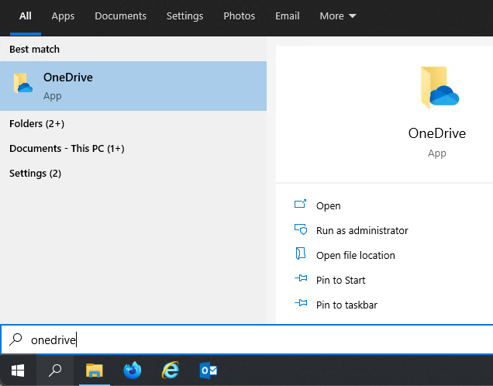

- Enter your TAMUS email address and click Sign in.

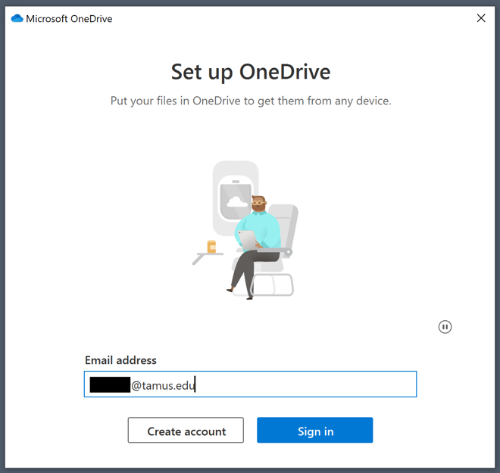

- Click the Work or school button (some users will not have this step).
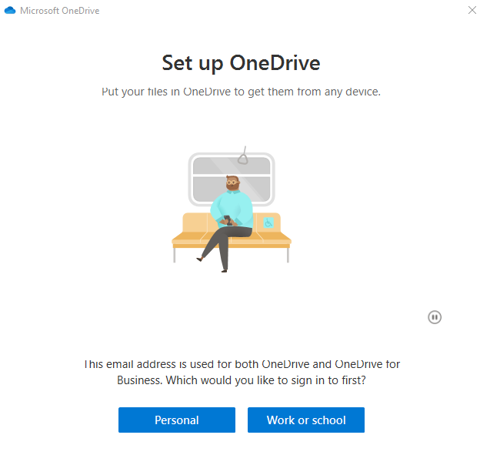

- Authenticate using DUO (some users will not have this step).

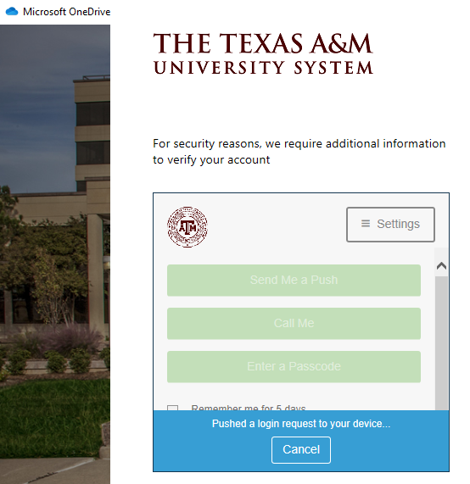

- Click Next.

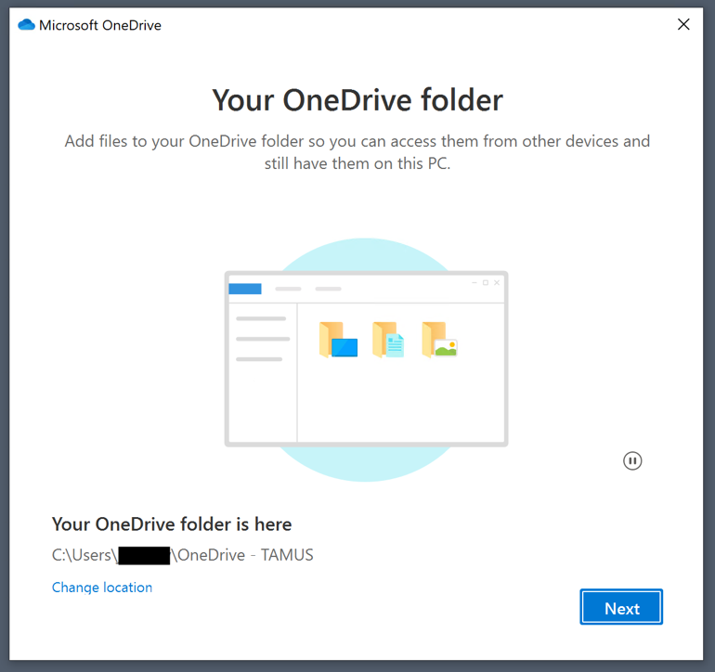

- Click Later on the “Get the mobile app” window.

- You will then be prompted to open your OneDrive folder. Click Open my OneDrive folder to complete the setup process.
After set up, your Desktop, Documents and Picture folders will sync to OneDrive. This can take some time.
Note: Items such as shortcuts, folders and other documents visible on your Desktop may briefly disappear and then reappear the first time you use OneDrive. This is an expected part of the setup process.
You should now see a OneDrive cloud icon near the clock in the Windows System Tray. Clicking on this icon will show the status of files that are being synced. It also has links to access your OneDrive folder and your OneDrive files online.
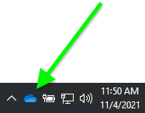

Where are my files?
You should now have a OneDrive – TAMUS folder in Windows File Explorer. You will find your folders and files that were copied from Syncplicity there along with your Desktop, Documents and Pictures.
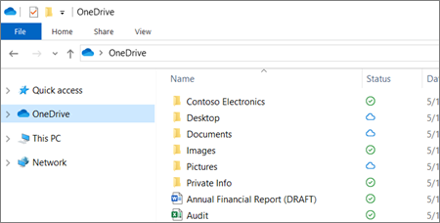

Where are files and folders that are shared with me?
Files and folders that are shared with you are available at the OneDrive website. Sign in with your TAMUS email address and the password you use for your work computer. Once you are logged in:
In the navigation area on the left, click Shared.
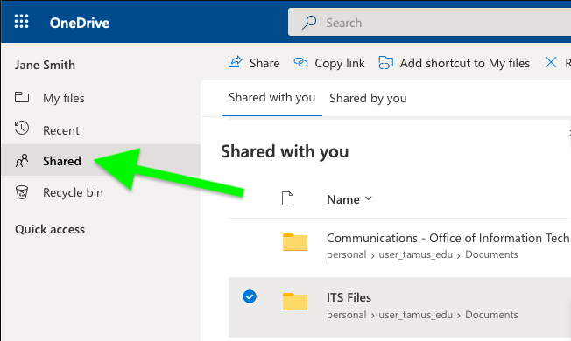

How can I access these shared files directly from my computer?
When someone shares a folder with you in OneDrive, it will only be available from the OneDrive website at first. You can make the shared folder available on your computer by adding a shortcut to it from the OneDrive website.
- On the OneDrive website, click Shared in the navigation area.

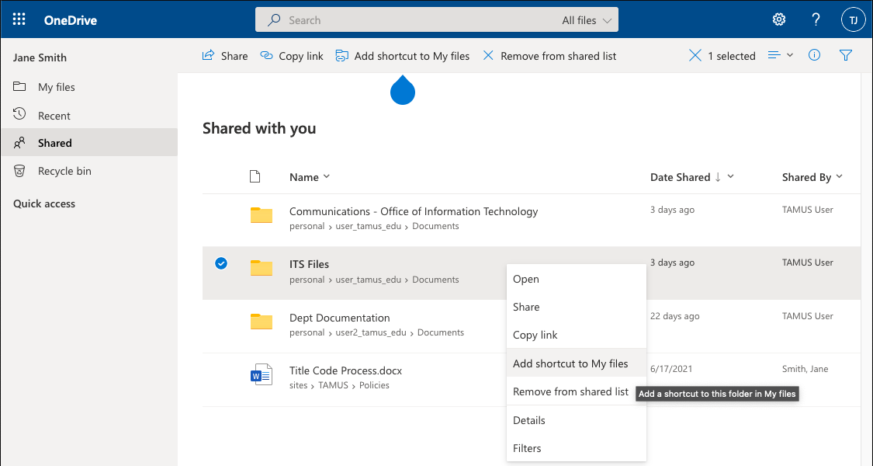
- Right-click on the shared file or folder you want to access from your computer, then select Add shortcut to My files. It may take a few moments to sync. It will then be available in OneDrive on your computer.

How can I share files?
To share from OneDrive on your computer or from the OneDrive website:
- Right-click a OneDrive file or folder and select Share. This will open a window with sharing options.
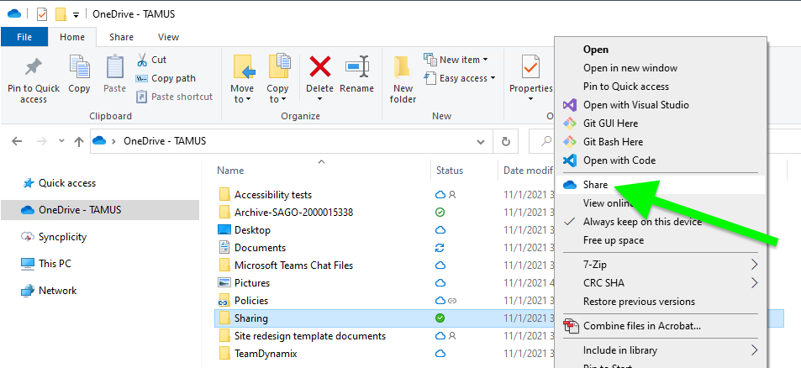

- Add the people you want to share with. Options include sharing with one or more people using their email address, copying a link for sharing and sharing through Outlook.

- Click the pencil icon drop-down button to change permissions. Allow editing is checked by default. To change permission to view only, uncheck this box and click Apply.

- Click Send after you have added the people you want to share with.
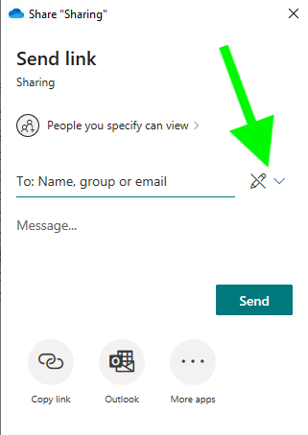
Learn more about sharing options in OneDrive.

How can I access files when I’m away from my work computer?
- Your OneDrive files are available at https://onedrive.com. Sign in using your TAMUS email address and the password you use for your work computer.
- OneDrive is also available for Windows, Mac, Android and iOS.

Some of my shortcuts stopped working, how can I fix that?
If you have shortcuts to files or folders located on your Desktop, Documents or Pictures folder, they will have to be recreated after OneDrive is installed. To recreate a shortcut:
- Delete the old shortcut.
- Navigate to the original file in OneDrive.
- Right-click on the file, then click Create shortcut in the menu.
- Move the new shortcut to the location you need it.

What do the icons next to each file mean?
Files and folders in OneDrive will have a status icon to indicate their sync state. Place your mouse cursor over an icon for a description of the status.

Common file and folder icons

The people next to a cloud icon indicates that the file or folder has been shared with other people.

Learn how to change sharing settings for OneDrive files and folders.
The circular arrows icon indicates that a sync is in progress.
A blue cloud icon indicates that a file is only available online. Online-only files don’t take up space on your computer.
When you open an online-only file, it downloads to your device and becomes a locally available file. You can open a locally available file anytime, even without Internet access.
If you need more space, you can change the file back to online only. Just right-click the file and select “Free up space.”
Learn more about OneDrive Files On-Demand.
Files that you mark as “Always keep on this device” have a solid green circle with a white checkmark.
These always available files download to your device and take up space, but they’re always there for you even when you’re offline.
New files or folders created online or on another device appear as online-only to save maximum space. However, if you mark a folder as "Always keep on this device," new files in that folder download to your device as always available files.
The “Always keep on this device” option is available when you right-click on any file or folder in OneDrive.

Learn more about these and other OneDrive icons.

Contact ITS Support: helpdesk@tamus.edu if you need assistance.

