Date: April 16, 2026

Time: 3 - 4 p.m.

Microsoft Teams Meeting

Withholding Orders for Employee Self Service – Anna McCoy

- Employees will be able to view active and historical Withholding Orders directly from their Worker Profile
- This would give them visibility into their own orders and reduce time fielding questions at HR and Payroll offices
- Employees will not be able to edit or make changes, updates will still require a support ticket submitted by your office.
- The Withholding Order for Worker report will now include the Total Debt Amount field, this will be available automatically.
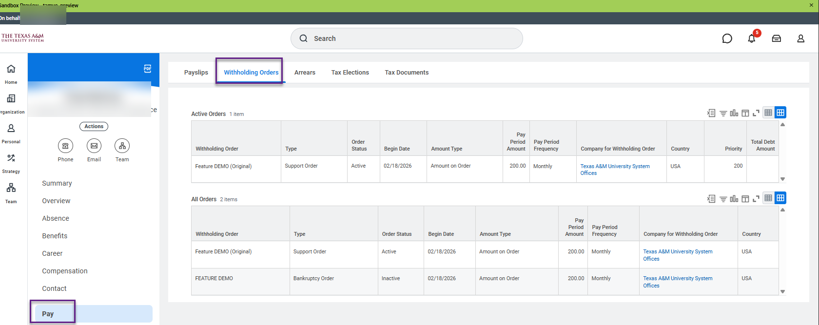

Reminder: Withholding orders submitted to the Service Desk, please include only the UIN in the support request subject line, and not the SSN for privacy and information security.

Vote: Do you support adding a new employee self-service tab for Withholding Orders? Received feedback that this might prompt more questions from employees. We will not be proceeding with adding the self-service tab

Payroll Report Updates – Sri Kamarthi

TRS Annual Statement

- Received a request for adding prompts and fields to TRS Annual Statement report.

Prompts
    - Location

Fields
    - TRS Employer Deduction
    - FYTD TRS Employee Deductions
    - FYTD TRS Employer Deductions
    - FYTD TRS Base Wages
    - YTD TRS Employee Deductions
    - YTD TRS Employer Deductions
    - YTD TRS Base Wages

Nonresident Aliens (NRAs) with FICA Deductions report

  - Does not include employees that have the NRA FICA exemption but do not require the “Nonresident alien” check box on the federal line.

  - Updates:
Add filters
- Federal Withholding: W-4 - Lock in Letter
- Citizenship Status contains "Non-Immigrant"
Add Columns
- W-4 lock in letter
- Citizenship status

EIB Due Dates – Sri Kamarthi

Pay Date | Due Date for Completed EIB Template
May 1, 2026 (MO) | Wednesday April 15, 2026
May 1, 2026 (BW) | Thursday April 23, 2026
May 15, 2026 | Thursday May 7, 2026
May 29, 2026 | Wednesday May 20, 2026
June 1, 2026 | Wednesday May 13, 2026

- The minimum is close to 50 as possible

- An authorized individual is the one submitting the Request for Mass Load (EIB) form on the Workday Help Website

- Please do not alter the formatting or add formulas to the spreadsheet

