Wednesday, December 3, 2025; Teams Meeting
ITOS Attendees: Anna, Ranil and Beto

Working Group Members – Roll Call Y or N
Name |  | Name |  | Name
Alissa Meyer (TAMUSA) | Y | Elizabeth Tschatschula-Jones (TDEM) | Y | Marissa Perez (TAMUCT) & Asia Terry | Y
Alicia Michalak (TFS) |  | Johnny Watson-Mendoza (TAMUT) | Y | Megan Groff (WTAMU)
Araceli Sandoval (TAMIU) | Y | Jessica Chapa-(TAMUK) |  | Sofia Rangel (TEES) | Y
Sarah Pedroza, Carmen Garcia (TAMU, TAMUG, HSC) & Noah Nettles | Y | Lindsey Hatfield (TARL) |  | Jessica Salazar (TTI) | Y
Christy White (ETAMU) | Y | Maria Pedigo (TAMUCC) |  | Tanesha Davis (PVAMU) | Y
Christin Spivey & Shaifali Mathur (AGEXT, AGRSCH, TVMDL) | Y | Meg Kleppel (TEEX) | Y | Vera Hobma & Dawn Santo (TAMUS) | Y
Evelyn Benoit and Connie (TAMUV) | Y

Previous Meetings Discussion/Voting Topics

United States Citizenship and Integration Services (USCIS) - End Automatic Extensions for Renewals of Lawful Work Permits – Sarah Pedroza
- USCIS is recommending Employees to start the renewal process 180 days prior to their Expiration Date.
  - Won’t impact other departments processes

- Guardian/Workday Notification Cadence Update Recommendations:
  - Workday currently sends notifications to the Employee, I-9 Processor, and I-9 Partner at 90, 60, and 30 days from the Expiration Date
  - Guardian currently sends notifications to the Employee and HR Groups at 45 days from Expiration Date

Emailed to Group; Action Item: Shaifali will confirm w/Immigration Affairs if they are updating reminder timeframes and will share any email correspondence she has on these topics.

- Vote: Add a new Workday notification reminder for 180 days prior to the Expiration Date?
Change Request 29288609 Release Date 12/11/2025:

- Vote: Update Guardian Expiring I-9 in 45 Day reports to also be sent at 180 days
Change Request 29288662 Release Date 12/11/2025:

New Request Regarding Notification Text (30/60/90)Day Work Authorization Documents Expiring – Sarah or Carmen
- We’ve received feedback that the Workday notifications should be reviewed, particularly to remove language that says the employees should notify their HR contacts that they need to prepare for their termination
- Email Drafts sent to I9 Group to decide on edits
Employee:
Our records indicate that your current work authorization will be expiring in "CF - DD - Days Until Work Auth Expiration Date on Worker" days on "CF - FD - Work Auth Expiration Date on Worker" . The purpose of this notification is to provide you sufficient time to take steps in preparation for extending your work authorization. This process will include obtaining the necessary documents and presenting this documentation to your Manager or HR office for Form I-9 reverification.

You must provide the necessary documentation on or before "CF - FD - Work Auth Expiration Date on Worker" to extend your employment beyond "CF - FD - Work Auth Expiration Date on Worker" . BE ADVISED: If your work authorization expiration date is not extended, you will need to inform your Manager or HR office to prepare for your pending termination from employment.

Please contact your department or Human Resources office with any questions or concerns.

Thank you,

- "Company" -

This is an automated email; do not reply.

I9 Partner:
Our records indicate that the Employee(s) listed below have work authorizations expiring soon. They received a notification through Workday advising them to obtain and present necessary documentation to their Manager or HR office for Form I-9 reverification.

The Employee(s) were advised to complete this process on or before the expiration date to extend their employment beyond that date. The notification also advised that if the work authorization expiration date is not extended, the Employee(s) will need to inform their Manager or HR office to prepare for their pending termination from employment.

This is an automated email; do not reply.

H-1B Portability – Sarah Pedroza
- H-1B Portability Days setting in Guardian
  - Guardian Description: When processing an H-1B I-9, the max number of days before the I-9 is considered expired. (Waiting for I-129 petition to be approved).
  - Currently set for 90 days (default is 30);
  - Reverification Dashboard shows when petition was filed, NOT 90 days prior to actual Expiration Date
  - Extensions up to 240 days after petition is filed?

- Knowing the Visa type on the EAD is now critical, should we consider turning on the Track Visa Type and Work Eligibility option?
  - Guardian Description: When checked, users are able to capture within the I-9 workflow class of admission and employment authorization category information for employees with temporary work authorization.
Meeting Discussions:
- Previous Vote was a NO, but to discuss again (now)
- H1Bs don't need EADs. Their dependents do (H4 EAD holder employees). EADs are mostly for F1 OPTs, J2 EADs
- Question for Tanisha (PVAMU) Do you depend on Workday/Guardian to be notified of H1-B expirations, or do you track it separately?
  - Answer: Rely on the automatic notifications, as they do not have an Immigration Services office, HR owns this process, and would like to have a 180 reminder

Action Item: Sarah will confirm tracking specifics on Guardian Help to ensure expectations are met, and will share with group before voting

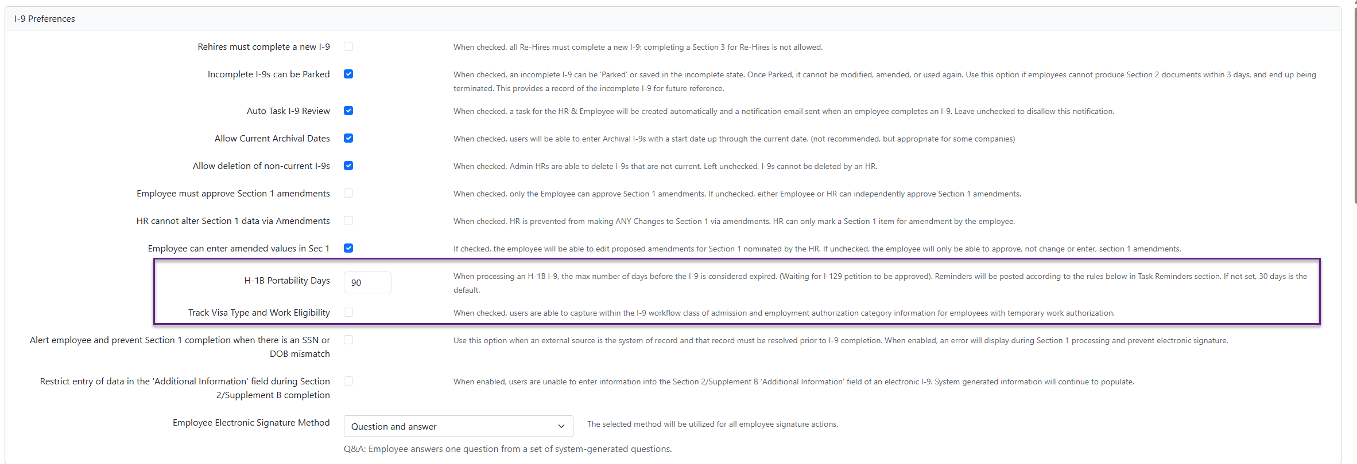
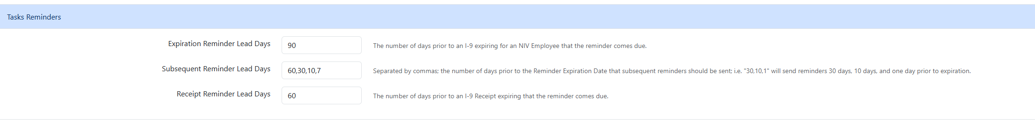

- Vote: Update H-1B Portability Days to 240 days?
- Vote: Check Box in Guardian to enable Track Visa Type and Work Eligibility?
Change Request for both 29288757 Release Date 12/11/2025

I9 Details Report Updates (Suggested by Operations):
- Based on conversations that Guardian I9 SSN Missing report is not helpful due to the Created by Date is used instead of Hire Date
- Add 4 Fields and a Prompt Check Box
  - SSN Missing – Yes or No
  - SSN Deadline – Most Recent Hire Date + 90Days (or 60 Days)
  - Current In Progress Government ID Event
  - Worker Country Location
- Minimal Reorder of Current Fields
Additional Questions:
- Confirmation: NEBO’s should NOT be included on the report
- Most Recent Hire Date: Currently report is only pulling most recent HIRE event. This does not include Transfers, Change Jobs, Add Jobs that are to a different Company. Should these events also be included in the report?

- Vote: Yes for Report Updates
Change Request 29193487 Release Date 12/11/2025

Future Working Group Meeting Frequency - Anna McCoy
- Options to consider:
  - Continuing monthly meetings
  - Move to every two months.
  - Move to quarterly meetings.
- Purpose:
  - Reevaluate cadence after transition from Workday Services to IT Operations.
  - Open discussion — no set preference by ITOS

Managing Questions from the group outside of the meetings? - Anna McCoy
- Pose question to ITOS, then we email the group?
- Email I9 Working Group Directly? Copy ITOS
- Pose question for Working Group meeting discussion?
- Favorites? Preferences? Exceptions (answer needed asap)

SSO Guardian Access Reviewed Quarterly? - Anna McCoy
- Confirm this is being completed by SSO Security Reviewers?

Member Guidance Requested Since Last Meeting
Collecting I9s in Workday in the past, are you converting them or creating them in Guardian?
Current I9’s are they being merged? Not merging or archiving in Workday.
Ag is keeping original I9s in Workday, and Section 3 happens in Workday
SSO – Guardian Button? Audits: We can do a clean up in SSO, but we will look into and give guidance via email.
Moved on from Analysis

Announcements

- Equifax is committing to start the migration to I9-HQ in Q4 of 2026
- A formal request to update the Termination Error Log to include the Employees Company Name, has been submitted to the Guardian/Equifax support team. Fingers crossed this is an easy change. Still Pending a Response
- A request for the I9 Guardian Error and the Exceeding Limit logs to be updated has also been submitted to our team. We have asked that when the error has been corrected, that both logs no longer include that record, and for the Company Name be included in the Exceeding Limit report. Still Pending a Response

Next Meeting – Second Wednesday - February 11, 2026 (February 7th is all day ITSS Professional Development Training.

