Wednesday, April 2nd , 2025
9:30 – 10:30 a.m.

Teams Meeting
Pamela Gentry; Julia Zimmerman

- Welcome & Roll Call
Name |  | Name |  | Name
Johnny Watson-Mendoza (TAMUT) | x | Lindsey Hatfield (Tarleton) | x | Christy White (ETAMU) | x
Alicia Michalak (TFS) | x | Vera Hobma (TAMUS) | x | Sofia Rangel (TEES) | x
Araceli Sandoval (TAMIU) | x | Elizabeth Jones (TDEM) | x | Tanesha Davis (PVAMU) | x
Carmen Garcia (TAMU,G,HSC) | x | Jessica Chapa (TAMUK) | x | Marissa Perez (TAMUCT) & Asia Terry | x
Christina Gomez (TAMUSA) |  | Shevonne Dyer-Phillips (TTI) | x | Maria Pedigo (TAMUCC) | x
Christin Spivey (AL, TVMDL) | x | Meg Kleppel (TEEX) | x | Megan Groff (WTAMU) | x

- Voting Items
  - .

- Discussion Items
  - 4/15 Guardian employee log in update
    - Will send out screenshot after meeting
    - What happens if the employee fails to authenticate?
    - Number of tries to authenticate?
    - Will add language to welcome email
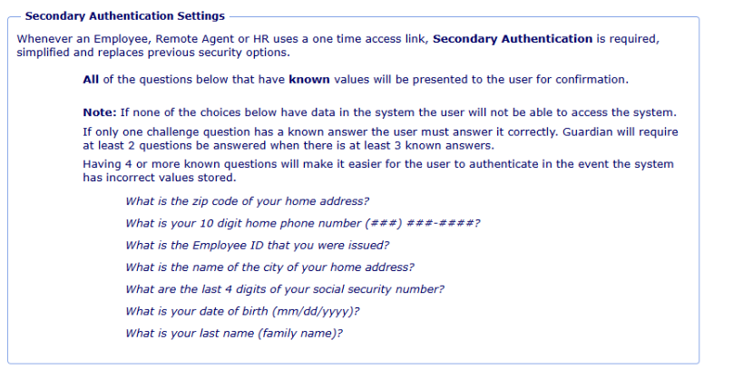
  - E-Verify Outage for I-551, Perm. Resident card, or I-766
    - Impacts E-Verify cases created March 23-26th, 2025
    - These cases may have incorrectly received a DHS mismatch (TNC) due to a system error. Please close and then resubmit any applicable cases in E‑Verify. If you have already submitted an additional case and received an Employment Authorized result for an affected employee, no further action is needed. You may see the message “E‑Verify Needs More Time” on the case status page appear longer than usual for affected cases, and E‑Verify will automatically close them.
  - I-9 Error Log Info sheet
    - Finalized- working with Training to be reviewed and posted to I-9 Help Website
  - Reminder: Review Dashboards in Guardian for old/incomplete I-9s & reverifications
  - MOU Contact Updates
    - All are completed
    - Further updates can be sent to Guardian Support

New Items:
  - (TAMU) Incorrect Citizenship Statuses being entered in Workday:
    - TAMU, G, HSC, AG(s), TEEX all see this as a common issue
    - Workers are entering wrong citizenship status in Workday. Way to verify Guardian and Workday match?
    - Update Onboarding To Do to add verifying citizenship status? - TAMU, HSC, TAMUG – Vote next meeting
    - Workday Citizenship drop down? Change order of options? - Ag(s) & TEEX see this as a common mistake - many people don't understand the difference between "Lawful Permanent Resident" and "U.S. Citizen". Because LPR is listed as the first option, people click on that without reading all the way down to see the Citizen option.

- Member Help
  - .

- Questions/Comments
  - .

- Action Items
  - .
Next Meeting: May 7th , 2025

