# Staffing Working Group

Tuesday, February 25th , 2025

2:00 – 3:00 pm

Teams Meeting

Pamela Gentry; Julia Zimmerman, D.J. Williams

## Welcome & Roll Call

| Name |  | Name |  | Name |  |
| --- | --- | --- | --- | --- | --- |
| Amber Cervantez TAMU, G, HSC | x | Jan Aspelund, TAMIU | x | Ivore Garza, Tarleton | x |
| Cassondra Casanova, TAMUCC | x | Valerie Townsend, PVAMU | x | Pam Young, WTAMU | x |
| Christina Gomez, TAMUSA | x | Johnny Watson-Mendoza, TAMUT |  | Robin Elliott, TTI | x |
| Dawn Santo, TAMUS (Vera Hobma) | x | Joy Bading, AL & TVMDL | x | Sharissa Berry, ETAMU | x |
| Derek Gonzales, TAMUK | x | Kristen Suehs, TFS | x | Warren Pitt, WTAMU | x |
| Erica Wallingford, TEES | x | Marissa Perez, TAMUCT (Asia Terry) | x | Wendoline Harrell, TEEX | x |
|  |  | Melinda Ho, TDEM | x | Yolanda Ballard, TAMUK | x |

## Voting Items

1. Add HR Contact to HR Partner Hub
   1. Vote: majority yes, 11 yes, 5 no
2. Skip manager approval in End Flexible Work Arrangement if initiated by HR Partner (not opt-in/out)
   1. Manager does receive a notification when the arrangement is ended
   2. Vote: majority yes, 11 yes, 4 no
      1. TAMUI – Wants feels it is the Manager’s responsibility

## WD 2025R1 Release Items

* 1. **Automatically Available in Production** **on 3/15/2025)**
     1. Service Dates now Effective Dated
        1. Correct Worker Start Date
           1. Service Dates Changes will be set to automatically rescind during the Correct Worker Start Date process, if the service date effective date conflicts with the new hire date
           2. Correcting the Worker Start Date automatically rescinds the Time Off Service Date associated with the Onboarding event. The Time Off Service Date will be reset based on six-month eligibility.
     2. Enhanced Resignation User Experience
        1. Submit and Withdraw Resignation from global search
        2. Renamed Fields
        3. Updated UI for Initiation and Reviews
     3. Change Job Templates New User Experience for Corrections
        1. Same look and feel as initiation step
  2. Set-up Required (for consideration – after 3/15/2025)
     1. Hire Reimagined
        1. Consolidated hire template (similar to change job)
        2. Will likely not use; not enough tasks to justify for now
     2. New Onboarding Experience
        1. In exploration; will likely replace current Onboarding Dashboard in future
     3. Workday Docs and Document Generation for Onboarding
        1. Looking at functionality for document accessibility purposes
     4. Job Description Generation on Job Profile
        1. Pay Plan Administration team will be testing in Sandbox after 3/15/25
     5. View Additional Organizations on Org Chart Side Panel
        1. An icon displays on the worker in the organization chart if the worker is in one or more of the following scenarios
           1. Manages more than 1 active supervisory org
           2. Has multiple positions
        2. Add in SB after release. This seems like a value add; no harm in having the information available.
        3. Will configure on 3/17 in Sandbox for working group to view

## Revisiting Deferred Release Items

* 1. Military Status Updates
     1. Moving to the Personal Information Change business process
     2. Removing custom object: State Military Preference and Veteran Preference functionalities
     3. Reports being updated to accommodate state and federal reporting needs
     4. Discussed and approved with System HR and OGC
     5. TAMIU: can “I do not wish to Self-Identify" be removed?
     6. Vote at next meeting
  2. Selective Service
     1. Adding to the Personal Information Change business process
     2. Do we want to start Employee Self –Service? And get rid of Other ID?
     3. Comments: May be helpful with AAP reporting
  3. Hire Optional Fields:
     1. Benefits Service Date - Hide (we don't use it)
     2. Company Service Date - Hide (we don't use it)
     3. Continuous Service Date - Not Enterable (see but not edit, it defaults to same as Hire Date and shouldn’t be edited)
     4. First Day of Work - Not Enterable (see but not edit, it defaults to same as Hire Date and shouldn’t be edited)
     5. Vote at next meeting

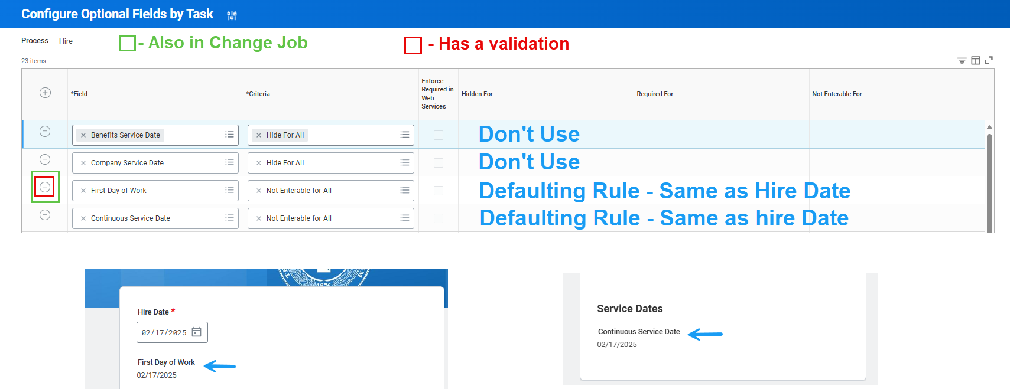

## New Items

* 1. (WDS/Reporting) Andrew Branch – Event Analysis Dashboard
     1. Plan to sunset
     2. What is useful on the dashboard that we do not want to lose?
     3. Tarleton: a lot of new people, not familiar with the dashboard
     4. TAMUC and TEES use it. TEES says it is helpful when processes get held up
     5. PVAMU: interested in similar reports for other areas (non-staffing)
     6. WDS: We currently only have a few people running it
     7. WDS: Potentially look at holistic vantage for reports (all areas, not just staffing)
  2. (From HAC) Add Vacation Payout Affidavit in Workday to launch with Submit Resignation? Termination?
     1. PVAMU - Packet sent through Docusign, as soon as Termination is submitted
     2. Member with paper form that gets manually sent to payroll: AG (will verify with absence partners), ETAMU, TAMUSA, TFS, TAMUCT, TTI,
     3. Some members do not offer exhaustion of vacation leave, so would need to be member optional
     4. Update: WDS is consolidating the information on the forms sent in by the members and will put together a recommendation
  3. Continue Discussion: (TAMUCC) 26668273 – Option to remove Department Head review for non-budgeted position Terminations (student workers and temp/casual)
     1. Current Review Options: Involuntary or All Terminations
        1. If we do this, the options would be Involuntary OR all Terms except Student & Temp Casual, which would mean no student or Temp casual positions would be reviewed
        2. Could add 3rd option Involuntary OR All Terms OR All Terms except Student & Temp Casual
     2. We have a couple members that do need to continue seeing Student and Temp/Casual
     3. TEES: We want the involuntary terms to require department review no matter the worker type. Non-budgeted positions could skip the department head if voluntary.
     4. Update: Appears to be enough interest to add the additional member option
     5. Vote at next meeting
  4. TEEX – Longevity Additional Job Classification not automatically removed when going from hourly to budgeted.
     1. Additional Job Classifications should be reviewed during the change job event to verify if any modifications are needed. No ALL budgeted employees get Longevity, Tenured Faculty for example.
     2. How do other members manage this?
     3. Should a warning be added to Change Job?

## Action Items

* 1. WDS – get together WG Facilitator expectations
  2. WDS – recommend solution for Vacation Payout in Termination BP
  3. Members – Event Analysis Dashboard review
  4. Members - Discuss Selective Service as Self-Service in Personal Information Change BP

## Completed Action Items

* 1. Staffing – send out one pager on Termination options – DONE
  2. Members to send in vacation payout forms

## Changes Completed

* 1. HR Partner Approval step is now a Review step in Request Flexible Work Arrangement
  2. View/edit permissions updated for Location Weekly Hours and Default Weekly Hours

## Upcoming Projects/Changes

* 1. Q2 - Mass Action for Change Job Templates
  2. Q2 - Safe Harbor – Mass Action for Termination
  3. Q2 - New Template – Updating End Dates for Temp/Casual
  4. New Templates – ALL reasons, by September 2025
  5. Q3 - Work and Home Contact forms – separate
  6. **Visiting Scholar** – Exploration for Workday as Record of Source
  7. **Nepotism, Consensual Relationship, External Employment** – exploration for Workday Solution
  8. Academic Module – exploration stage
  9. Military Preference – Moving to Personal Information Change business process
  10. Selective Service – Moving to Personal Information Change business process

1. Old Items (Pending/On Hold)
   1. Exit Survey Enhancements
   2. Worker Documents and Purge
   3. Due Dates – Consolidated list of current Due Dates to review

Next Meeting: March 25th