Tuesday, December 17th, 2024

2:00 – 3:00 pm

Teams Meeting

Pamela Gentry; Julia Zimmerman, D.J. Williams

1. Welcome & Roll Call

| Name |  | Name |  | Name |  |
| --- | --- | --- | --- | --- | --- |
| Amber Cervantez TAMU, G, HSC | x | Jan Aspelund, TAMIU |  | Claudia Azua, Tarleton |  |
| Cassondra Casanova, TAMUCC |  | Valerie Townsend, PVAMU | x | Pam Young, WTAMU | x |
| Christina Gomez, TAMUSA |  | Johnny Watson-Mendoza, TAMUT |  | Robin Elliott, TTI | x |
| Dawn Santo, TAMUS | x | Joy Bading, AL & TVMDL | x | Sharissa Berry, TAMUC | x |
| Derek Gonzales, TAMUK | x | Kristen Suehs, TFS | x | Warren Pitt, WTAMU |  |
| Erica Wallingford, TEES | x | Marissa Perez, TAMUCT (Asia Terry) | x | Wendoline Harrell, TEEX | x |
|  |  | Melinda Ho, TDEM | x | Yolanda Ballard, TAMUK | x |

1. Voting Items
   1. Remove Manager from Initiation of BPs (will vote on each BP individually)
      1. Before voting, will ask for any objections to specific BPs
         1. Switch Primary Job – Yes Vote: 12-0
         2. Close Position – Sub Process of Close Requisition, Recruiting Working Group will need to vote - Yes Vote: 12-0
         3. Contract Contingent Worker - Yes Vote: 12-0
         4. Create Position – Sub Process of Job Requisition, Recruiting Working Group will need to vote - Yes Vote: 12-0
         5. End Contingent Worker Contract - Yes Vote: 12-0
         6. Request FWA - Yes Vote: 12-0
         7. End FWA - Yes Vote: 12-0
         8. Photo Change - Yes Vote: 12-0
         9. Change Work Space - Yes Vote: 12-0
         10. Freeze Position - Yes Vote: 12-0
2. Completed Action Items
   1. Members – Test HR Partner Hub
   2. Members – Discuss Student Job Profiles with Pay Plan Administration
   3. Members – Discuss Department Head Review in Termination, for Student and Temp Casual positions
   4. WDS - Review Switch Primary Job Manager Approval – can it be optional? - DONE, discussion item below
3. New Items
   1. Continue Discussion: (TAMUCC) 26668273 – Option to remove Department Head review for non-budgeted position Terminations (student workers and temp/casual)
      1. Current Review Options: Involuntary or All Terminations
         1. If we do this, the options would be Involuntary OR all Terms except Student & Temp Casual, which would mean no student or Temp casual positions would be reviewed
         2. Could add 3rd option Involuntary OR All Terms or All Terms except Student & Temp Casual
      2. Will continue to discuss at next meeting. Members still discussing.
   2. Continue Discussion: (WDS/TEES) Add HR Contact to HR Partner Hub
      1. Currently only the HR Partner can access the HR Partner Hub
      2. Received some testing/feedback from members. Will continue to discuss. Not voting yet.
   3. Manager Approval in Switch Primary Job
      1. Options: Make opt in/out OR do not trigger if student positions at same company
      2. Vote at Next meeting – Add condition for student position at same company
   4. (WDS) Weekly Hour fields in Hire, Change Job, Add Job
      1. See screenshot below – Do you use/look at the Location Weekly Hour field, or can we hide it? Can we lock the Default Weekly Hours field since it is always 40? Would still be visible, just not editable.
      2. No concerns. Will be voted on during January 2025 HAC meeting

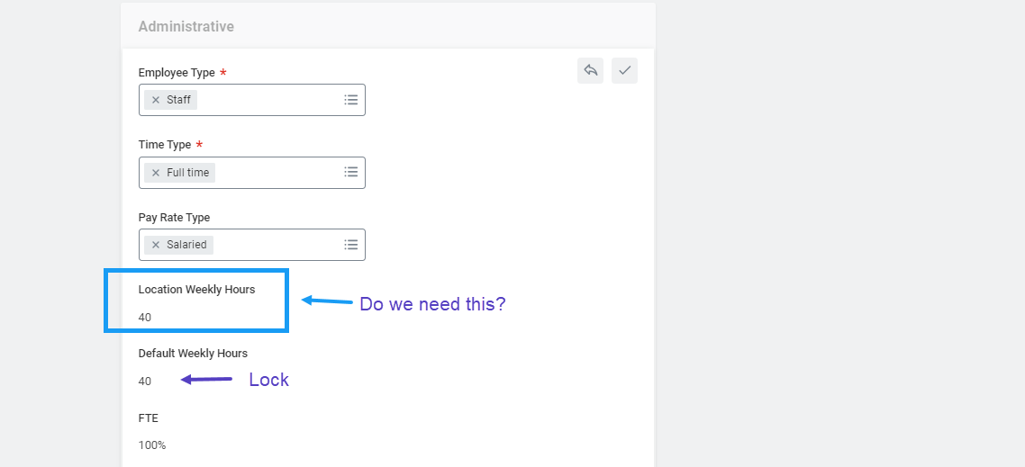

1. Changes Completed
   1. Warning in Change Job if Worker has FWA that needs to be ended
   2. New Transfer Reason for Organization Changes
   3. Change Job Templates – 12/19/24
2. Upcoming Projects/Changes
   1. Q2 - Mass Action for Change Job Templates
   2. Q2 - Safe Harbor – Mass Action for Termination
   3. Q2 - New Template – Updating End Dates for Temp/Casual, Comp Change
   4. New Templates – ALL reasons, by September 2025
   5. Q3 - Work and Home Contact forms – separate
3. Old Items (Pending/On Hold)
   1. Exit Survey Enhancements
   2. Put Exit Interview Functionality in SBX
   3. Worker Documents and Purge
   4. Due Dates – Consolidated list of current Due Dates to review

Next Meeting: January 28th, 2025 (See you next year!!)