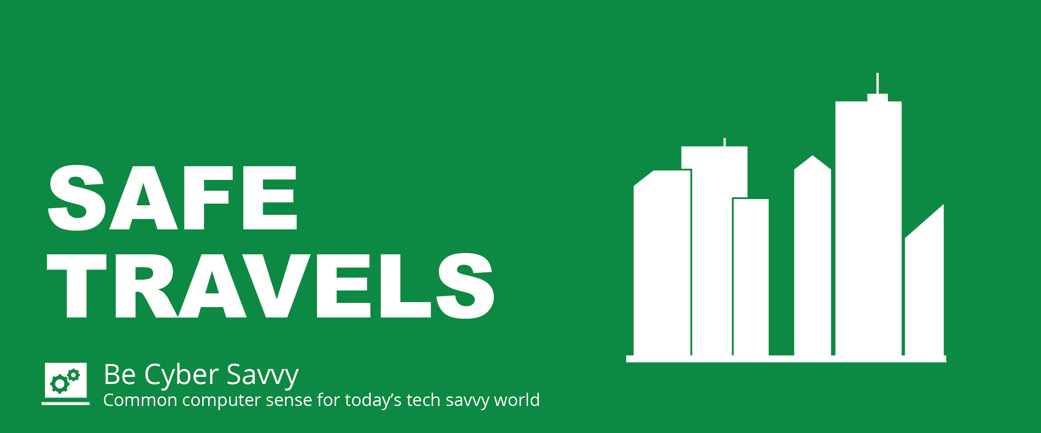

Whether you travel for work or pleasure, CyberTrip Advisor is your resource for keeping you cyber safe when you travel.

When traveling and using public Wi-Fi, others can gain access and see what’s on your device. Turn off Bluetooth, cellular services and Wi-Fi when you are not using them. Limit what you do on public Wi-Fi and avoid logging in to accounts that have sensitive information.

Don’t take protected data overseas and when possible, don’t take A&M System assets with you when traveling. Use a loaner device when travelling abroad.

Be sure to review and follow A&M System and your organizations policies regarding:
Export Controls
Portable Device Usage

Reach out to your Information Security Officer for more information.

