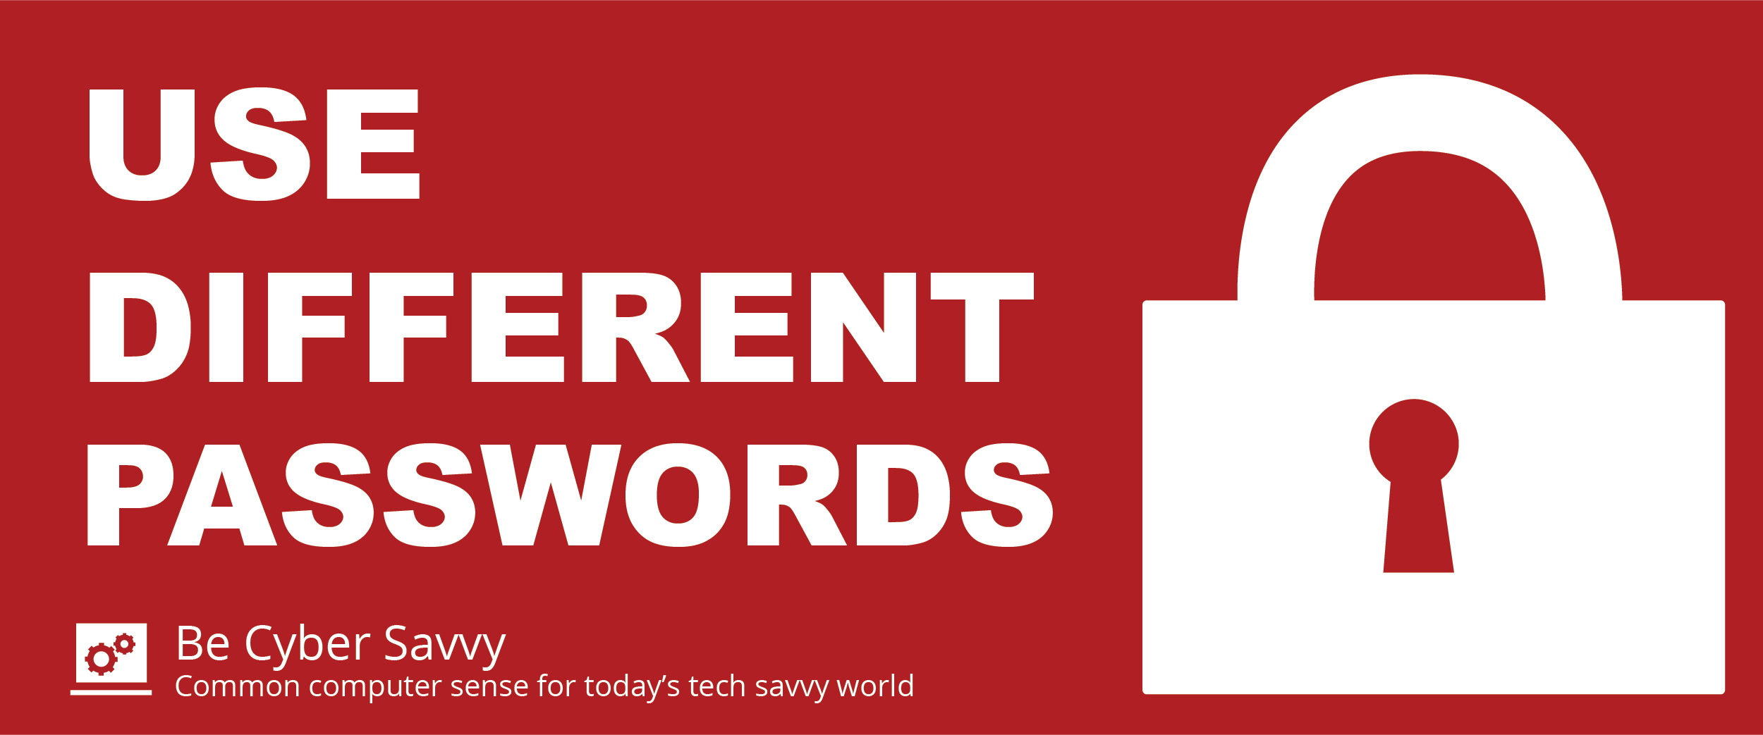

Refuse to reuse!
It’s risky to use the same password for all of your accounts. Use a unique password for every account.

Can’t remember all of those passwords?
Use a password manager, such as LastPass, for online accounts and services. A password manager easily generates and stores passwords that are unique to each service, removing the need for you to remember or type in online passwords.

Check haveibeenpwned.com to see if any of your accounts have been compromised

Reach out to your Information Security Officer for more information.

