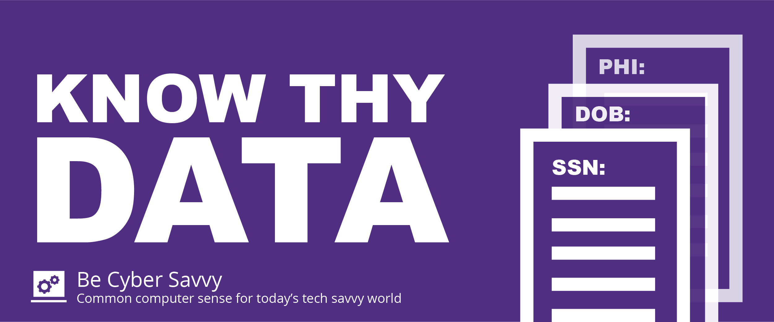

When in doubt, don’t send out!
Do you work with personal information like social security numbers, employee dates of birth, applicant information or personal health information?

Use a secure means of sending data when necessary.

Secure sensitive data by following both A&M System and your organizations policies:
Data Classification and Data Protection
Encryption of Confidential and Sensitive Information
Data Breach Reporting

Reach out to your Information Security Officer for more information.
If you don’t need it, delete it!

